Executive Summary
IeC believe a Great Unwinding is now underway of the policymaker stimulus that has dominated markets since 2009. This has been inevitable for some time, with the key questions being around timing and the potential implications.

Developments over the summer led us to conclude that this Unwinding was about to begin. Thus these 5 blog posts, beginning on 18 August, alerted clients to the changes that we now expect to see in oil markets, the value of the US$, interest rates and the S&P 500.

The first post highlighted the overall concept of the Great Unwinding. The second post analysed why oil prices would likely fall very sharply. The third post suggested the US$ would simultaneously rise very sharply, and the fourth post looked at the ambiguous outlook for interest rates. Finally, we suggested the S&P 500 could see a major fall.

IeC has won a reputation for independent thinking since it correctly forecast between 2006-8 in the Financial Times and elsewhere that the US subprime market would cause a major financial crisis. These posts represent a recent example of our continued ability to see beyond the consensus viewpoint, and highlight the key issues for the future.

CONTENTS Page
Executive Summary and Contents 1
- The Great Unwinding of policymaker stimulus has begun 2
18 August 2014
- Oil prices break out of their triangle - downwards 3

27 August 2014
- US dollar rises as investors worry low-cost money may disappear 6

3 September 2014
- The Great Unwinding of policymaker stimulus creates interest rate risk 8

10 September 2014
- Shiller warning suggests S&P 500 bubble coming to an end 10
17 September 2014
The author 14

The blog posts appear here in unrevised form, as they appeared at http://www.icis.com/blogs/chemicals-and-the-economy/

1. The Great Unwinding of policymaker stimulus has begun
By Paul Hodges on 18 August, 2014 in Economic growth

Large economies are like supertankers. There are no brakes to use if you want to change direction in a hurry. Instead, you have to put the engine into reverse, and hope you can slow down fast enough to avoid the rocks.

That is what happened in China last month, as the new leadership began to unwind the largest lending bubble ever seen. Short-term corporate loans, the lifeblood of small companies, fell by Rmb 236bn ($38bn).

In pre-Supercycle days this would have been called a “credit squeeze”. Suddenly, credit tightens and investors worry about ‘return of capital’ instead of ‘return on capital’. Or as the blog’s major Research Note on China in February was titled:

“China Bank Lending: from $1tn to $10tn and Back Again?”

At the same time, gold sales are tumbling, with jewellery sales collapsing 45% in Q2. Clearly China’s anti-graft campaign is hitting its targets - no official would now dare to wear a new gold watch.

Elsewhere in NEA, GDP fell 6.8% in Japan. Abenomics, as expected, is coming to an end of its life as a supposed ‘miracle cure’ for the world’s third largest economy. As former Bank of Japan Governor Shirakawa keeps reminding us:

“The main problem in the Japanese economy is not deflation, its demographics. The issue is whether monetary policy is effective in restoring economic recovery. My observation is, it is quite limited.”

Thus the Great Unwinding of the failed stimulus policies since 2008 has now begun.

Over on the other side of the world, financial markets are slowly beginning to rediscover their role of price discovery. For 6 years, central banks have supplied them with endless amounts of free money. This has forced prices upwards in what became known as the ‘correlation trade’.

But now, oil markets are starting to follow cotton and other commodities in refocusing on the fundamentals of supply and demand. And as the International Energy Agency noted in its latest monthly report:

“Oil supplies were ample, and the Atlantic market was even reported to be facing a glut”, whilst Reuters reported that ”implied oil demand in China fell 6% last month“.

In Europe, hopes that stimulus policies will finally lead to a sustained recovery are also unwinding. The Eurozone economy failed to grow in Q2: Germany’s economy declined; France showed no growth; Italy fell back into recession.

Meanwhile in the USA, retail sales were flat in July, whilst housing remains weak due to demographic factors. This is a bad omen for GDP, as consumer spending is more than two-thirds of the economy. Thus we are likely to see a repeat of the pattern described last week by the new deputy chairman of the US Federal Reserve, Stanley Fischer:

“Year after year we have had to explain from mid-year on why the global growth rate has been lower than predicted as little as two quarters back”

Even more alarming, as Nobel-prize winner Prof Robert Shiller warned yesterday, is that the Cyclically Adjusted Price/Earnings (CAPE) ratio for the S&P 500 - the best predictor of long-term stock market returns - is now:

“Above 25, a level that has been surpassed since 1881 in only three previous periods: the years clustered around 1929, 1999 and 2007. Major market drops followed those peaks.”

Of course, nothing is certain in this world apart from death and taxes. But there are clearly signs that the long-awaited Great Unwinding is now underway. The blog will start to look at the potential impact of this in 4 key areas next week – oil prices, exchange rates, interest rates and equity markets.

- Oil prices break out of their triangle – downwards
By Paul Hodges on 27 August, 2014 in Oil Markets, Futures trading
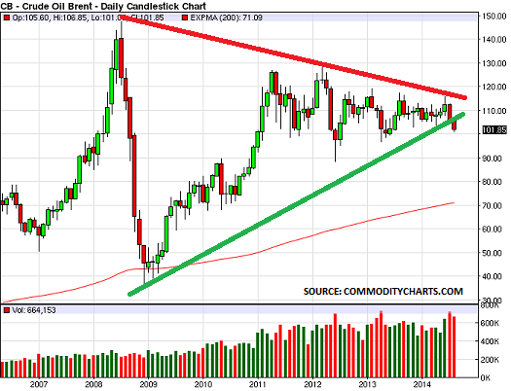

The Great Unwinding of the central banks stimulus policies is underway, as discussed last week. Oil markets have been one of the first to feel the change, as the chart shows, with prices finally falling out of the ‘triangle’ shape built up since 2008. The value of the US$, interest rates and the S&P 500 will also be impacted as the Unwinding continues.

The ‘triangle shape’ is one of the most interesting ’technical’ shapes. It monitors the balance of power between the bulls (seeking to push prices higher) and the bears (trying to take them lower). And the oil triangle since 2008 has been particularly interesting as in reality it has monitored the balance between:

- The financial players, trading electronically on the futures markets second by second
- The physical players, actually using the product for transport, heating and other ‘real’ purposes

Essentially what has happened is that the market long-ago stopped being based on supply/demand fundamentals. Instead it became driven by financial players. In hindsight, we can see there were two stages to this development:

Stage 1, 2005 – 2008
- Investment banks had made easy gains from 2005 onwards, by buying large volumes of futures contracts
- Prices then collapsed back to the historical $30/bbl level at the end of 2008

Stage 2, 2009 – 2014
- Prices recovered sharply as central banks began printing cash on a low-cost model with low interest rates
- Pension funds bought oil as a ‘store of value’, as the US Federal Reserve devalued the $ to boost exports
- Investment banks created hype about supposed shortages, whilst hedge funds jumped in to follow the trend
- High-frequency trading added to the chaos, creating the ‘correlation trade’ with the US S&P 500 Index

One set of statistics highlights the change that took place (data from ThomsonReuters):

- 2005: Just 920,636 contracts were traded in the US WTI futures market
- 2008: There were 21,485,557 contracts traded
- 2011: There were 41,943,006 contracts traded

Futures markets had originally been created to allow producers and consumers to hedge positions. The blog helped to develop the contract in its early days when working for ICI in Houston, Texas. It still believe they have a valid purpose.

But as the blog noted as long ago as July 2010, the financial players’ strategy have reversed the normal working of the markets. They have created a contango structure, where prices for future delivery are higher than today’s.
This is the opposite of the traditional role, where producers hedge their positions and create backwardation – making today’s price higher than tomorrow’s.

FINANCIAL PLAYERS CAME TO DOMINATE OIL MARKETS
Thus oil markets have thus lost their price discovery role since 2005, and have instead been swamped by financial players.
- In 2005, world oil production was 82 million bbls/day of crude: WTI hedging was less than 1 million bbls/day
- By 2011, world oil production was still only 84 million bbls/day: but WTI hedging was now half of the total

History shows that the global economy cannot support oil prices being more than 2.5% of GDP. But since 2009 they have taken 5% of GDP, due to the actions of the financial players. The gap has been bridged by the central banks, creating $35tn (50% of global GDP) of new money on a low-cost basis over the period.
Naturally, prices soared as all this new financial demand appeared. The reason is simple: it takes only a microsecond to create a trade on a futures market, but it takes at least 5 – 10 years to find new oilfields and bring them into production.

Speculators thus began to dominate the market, creating a completely artificial balance between supply and demand – based on financial flows instead of product flows.

THE GREAT UNWINDING OF STIMULUS IS NOW UNDERWAY
But now the central banks are starting to pull back. Logic says you can’t go on printing money forever – in the end, you have to start paying it back, or defaulting.

China was the first to do this last year under the new leadership. Thus Reuters reports its implied oil demand was down 6% in July. Now, the International Energy Agency has
reported in its latest Report that:

“Oil supplies were ample, and the Atlantic market was even reported to be facing a glut”

Thus the oil price is finally starting to fall out of its triangle:

- 10 years of historically high prices has led to major new investment, which is finally starting to come online – not only in oil, but also in gas and other energy sources
- At the same time, central bank lending is finally starting to reduce in China and the US
- 10 years of high prices have also led to demand destruction via greater efficiency and conservation efforts
- The result, as the IEA note, is that we suddenly find we face a supply glut

So the chart is telling us that the financial players are now retreating from the market. In turn, this means physical supply/demand levels will come to drive the process of price discovery once again.

MAJOR OIL PRICE VOLATILITY IS NOW LIKELY
How low will prices go? We can have no idea, as prices have never been this high for so long. Nor can we rule out a further massive stimulus effort by the central banks at some point. But ‘technical trading’ logic would suggest they will fall to at least the 200-day exponential moving average, currently around $70/bbl, and probably lower (red line).

Equally, if price discovery does start to become based on real supply/demand balances again, we will have to watch out for geopolitical issues.

Ironically, there was never a single moment when supplies were interrupted whilst prices were high. It was all hype, as the blog described at the time. But today there are real concerns developing on the supply side.

Will Russia cut Europe’s gas supply through the Ukraine in the winter, for example? That could easily push oil prices much higher, as users panicked and tried to substitute oil for gas.

Companies need to urgently prepare for major and unprecedented volatility in energy markets, as the Great Unwinding continues.

US dollar rises as investors worry low-cost money may disappear
By Paul Hodges on 3 September, 2014 in Financial Events
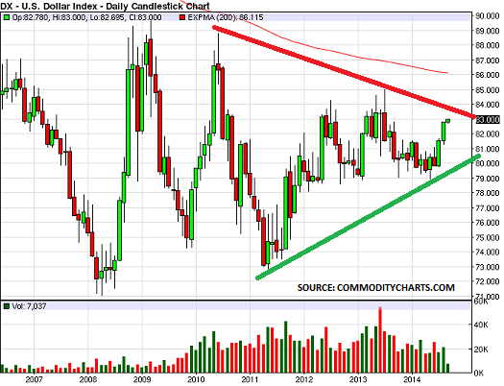

Nobody knows how the Great Unwinding of central bank stimulus policies will develop. The world has simply never been in this position before. Thus the senior economics and business correspondent of the Financial Times, John Plender, began an article this week:

“In a market where asset prices are comprehensively rigged by central bankers, rational investment becomes impossible. Discuss.”

Exchange rates have been a key target for central bankers:

- The US Federal Reserve tried to boost exports by devaluing the US$
- The Bank of Japan has aimed at devaluing the yen to boost exports and inflation
- The Bank of England has aimed to devalue of the pound
- Now the European Central Bank is trying to devalue the euro

The problem is that these interventions are on such a scale that markets have become unable to fulfil their key role, of price discovery. We simply don’t know the real prices at which currency markets would trade, if central banks were not dominating the financial flows.

Thus the road back from financial stimulus, the Great Unwinding, is likely to be bumpy at best and will probably become quite scary.

The chart above of the US$ Index highlights the position:

- It has fluctuated 25% on several occasions between 72 and 90 since the middle of 2008
- First there was a ‘flight to safety’ in H2 2008, as the Financial Crisis took place
- Then the US Fed pushed the value down again with its first Quantitative Easing (QE)
- When traders tried to buy the US$ again in 2010, new QE programmes kept the $ weak

Thus as with crude oil, the US$ Index has traced out a large triangle. This suggests that the US$ would rise, if the Fed stopped trying to push it down.

Importantly also, the chart shows a strong move upwards is again underway. This is probably also connected with a growing sense that hopes for strong economic growth in Europe and China are simply wishful thinking.

These US$ and crude oil moves are self-reinforcing. Pension funds bought into oil markets as a ‘store of value’, as they saw the US$ being devalued. So if the US$ is rising, they have no need to buy oil and other commodities.

But will the US Fed allow this move to continue? Recent speeches by the new Fed Chairman, Janet Yellen, have been equivocal at best, suggesting she is not clear about the best policy to adopt. There is also the fact that to some extent, events are moving out of central bank control, particularly with the Ukraine situation hotting up.

If we assume for a moment that the US$ continues to rise, then the recent flows of money into high-risk assets will quickly reverse. These have been largely created by the Fed’s
decision to supply unlimited amounts of low-cost money:

- Pension funds and hedge funds have simply bought anything that offered a high yield, in a desperate effort to maintain their returns for investors and pensioners
- They have only thought about the need to focus on ‘reward’, and have ignored the fact that high reward usually also means ‘high risk’

But if money flows back into the US$, then ‘risk’ will return with a bang. Who will buy all the assets that are being sold?

This is the great unknown ahead of us. One key area of risk is the future direction of interest rates. Will these remain low, or will investors suddenly realise that the debt they bought so happily may never be repaid? Equally, will investors start to question whether today’s high equity prices can be maintained, if growth remains slow?

We cannot know the answers to these questions. But prudent companies and investors will need to spend time developing their ideas about potential Scenarios. It could be very dangerous indeed to simply assume that the unique circumstances of the past few years will become permanent

The Great Unwinding of policymaker stimulus creates interest rate risk
By Paul Hodges on 10 September, 2014 in Currencies

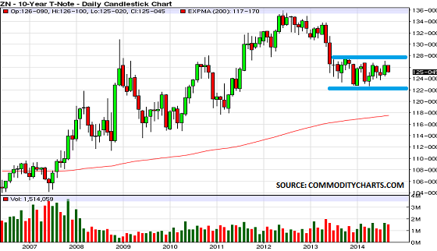
Interest rate risk is rising in the developed economies as the Great Unwinding of policymaker stimulus continues. Since the blog first highlighted this Unwinding last month:

- Oil prices have continued to tumble, with Brent now down over $15/bbl from its late-June peak
- The US$ has continued to rise from multi-year lows versus the yen, euro and pound

And of course, these developments are self-reinforcing. Pension funds are now losing money on their oil market positions. They also have no reason to own oil as a ‘store of value’ if the US$ is strengthening.

In turn, these developments also impact interest rates and equity markets. The blog looks at interest rates today, and will then complete its mini-series next week by focusing on equities. As the chart shows:

- The US 10-year bond fell last year, as US investors believed economic recovery had become certain
- In turn, this caused interest rates to rise, as bond prices are the inverse of interest rates
- But more recently, the downward trend has halted, much to the surprise of the ‘experts‘
- The 10-year Treasury bond has thus been trading in a narrow band this year (blue lines)

This confirms it has been China’s reversal of economic policy that has changed financial market direction. US Federal Reserve cutbacks have been relatively minor by comparison. As the blog warned in February, when publishing its major Research Note (China bank lending: From $1tn to $10tn and back again).

“Why did nobody notice that China was the ‘elephant in the room’, in terms of being the main cause of today’s downturn in global demand and financial markets?” Answer: “Because we were all wearing rose-tinted glasses”.”

The question today is what happens if China’s housing bubble continues to burst?

- 49 million homes in China’s urban areas have been sold to speculators and sit empty today – more than 1 in 5 of the total - and $674bn of mortgage loans are secured on them
- Financing for the bubble has mainly come from Asian investors and the shadow banking system, so lenders to both these sectors will face big losses
- It will also undermine the ‘collateral trade’, so large quantities of iron ore, copper and even polymers will flood global markets in a disorderly fashion
- Most likely therefore, this will put further pressure on oil prices and strengthen the US$, reinforcing current trends
- But it will also focus attention on the key issue of debt repayment (as well as the outlook for company earnings)

We cannot know how markets will react:

- They might decide to see US markets as a ‘safe haven’ and dump debt in weaker currencies, such as the yen, euro and pound. If this happened, US interest rates could fall sharply
- Alternatively, investors might be forced to raise cash quickly to meet margin calls*, if commodity markets start to dive. This could force them to sell low-risk assets such as US Treasuries, causing interest rates to rise

This is one of the reasons why the blog fears we may see scary moments as markets slowly recover their prime function of price discovery. The collapse of the Chinese housing bubble will not just impact China – in fact, its biggest impact may well be felt outside China.

The reason is that, as the blog suggested back in June, China’s earthquake will open fault-lines in today’s debt-fuelled global ‘ring of fire’

*Margin debt is at record levels in New York markets, so this might be the only way to meet ‘margin calls’ (these are brokers’ demands to make immediate payment if prices have fallen during the day).

Shiller warning suggests S&P 500 bubble coming to an end
By Paul Hodges on 17 September, 2014 in Financial Events

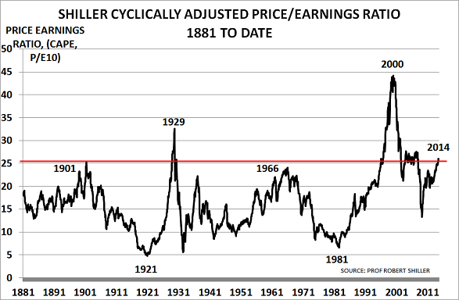

Nobel Prize-winner Prof Robert Shiller correctly forecast the dot-com collapse in 2000, and the 2008 financial Crisis, using the chart above. Now he is warning we risk a 3rd collapse.

The problem is that Western central banks have undertaken the largest financial experiment in history. Their policy has been to boost financial markets, particularly the US S&P 500 - the world’s most important equity market index.

This policy has failed twice before in 2000 and 2007, and Shiller fears we will now see a further collapse. This is a major risk as today’s Great Unwinding of policymaker stimulus gets underway.

US STOCK MARKET VALUATIONS ARE AT DANGEROUS LEVELS
Shiller’s original insight was that it was possible to recognise when investors had become over-enthusiastic:

- Traditional values for the P/E ratio simply divide the daily market price by current earnings
- But Shiller’s CAPE version instead uses average earnings across the 10-year business cycle*

Using a 10-year average for earnings enables his CAPE Index to highlight peaks and troughs in investor enthusiasm.

The ratio shot to fame in 2000, when published in Shiller’s book Irrational Exuberance, where Shiller correctly argued that markets were about to collapse:
- 1929 had been the only previous example when markets had traded above a CAPE ratio of 25 (red line)
- But in 2000, the ratio surged to nearly 45, as central banks allowed the dot-com mania to develop
- Until then, they had seen their role as being “to take away the punch-bowl as the party develops“
- Instead, under Fed Chairman Alan Greenspan, they came to believe their role was to support the stock market

Over the past 15 years, stock markets have become more and more dependent on central bank support. As we noted in chapter 2 of Boom, Gloom and the New Normal, Bank of England Governor Eddie George explained the policy to the UK Parliament in 2007 as follows:

“When we were in an environment of global economic weakness at the beginning of the decade it meant that external demand was declining… we knew that we had to stimulate consumer spending. We knew that we had pushed it up to levels that could not possibly be sustained in the medium and longer term…That pushed up house prices and increased household debt. That problem has been a legacy to my successors; they have to sort it out.”

But central banks have since refused to remove this ‘life-support’ and have instead increased it to all-time record levels, whilst taking interest rates to all-time record lows. As then US Fed chairman Ben Bernanke boasted in January 2011:

“Policies have contributed to a stronger stock market just as they did in March 2009, when we did the last iteration of this. The S&P 500 is up 20%-plus and the Russell 2000, which is about small cap stocks, is up 30%-plus.”

Shiller, like Warren Buffett and the blog, is a follower of Ben Graham’s work. Known as the ‘Father of Security Analysis’, Graham developed a simple formula to explain the importance of the Price/Earnings ratio:

- He showed that a P/E ratio of 8.5 meant markets were expecting zero earnings growth over the next 10 years
- Each 2 point change, up or down, meant they expected earnings to rise or fall by 1% a year for the next 10 years

Thus today’s CAPE ratio of 26.5 means investors are expecting S&P 500 earnings to rise by 9%/year till 2024. Yet earnings are already at near-record levels, so this is clearly impossible. Hence Shiller’s concern that the market is heading for a collapse.

For a fuller analysis by the Harvard Business Review of Graham’s pioneering work, and its triumphant confirmation during the 1987 stock market crash, please click here.

CENTRAL BANK STIMULUS HAS FAILED TO SUSTAIN CONSUMER SPENDING
Despite all their efforts, it is clear today that the central banks’ policy has failed. The main US Consumer Confidence Index remains well below Boomer-led SuperCycle peaks. Instead, we are moving into the Boomer-led New Normal, where spending will be much lower due to the impact of globally ageing populations.

Sensible central banks would have celebrated the fact that life expectancy has increased by 50% since 1950 across the world. They would have accepted that demand must slow as a result – particularly as fertility rates had fallen by 50% over the same period. After all, only people can create demand.

Instead of increasing debt levels, they would have ensured that the budget surpluses of the late-1990s were maintained, in order to pay the bills for pensions and healthcare spending.

But they chose to deny the impact of this demographic change, and so have instead created a ‘debt-fuelled ring of fire’. China’s reversal of its stimulus policy is the initial earthquake that is now opening up the fault-lines they have created.

Thus it seems that the Great Unwinding of these failed policies is now underway. We can have no idea how it will end.

As Shiller’s chart shows, the modern world has never seen such an experiment in monetary policy carried out on such a scale, and for so long. It highlights how policy has become entirely focused on the progress of the S&P 500:

- Policymakers believe that as long as it continues to climb, everything must be going well in the wider economy
- Thus they are ignoring China’s reverse-course, just as they ignored early signs of collapse in sub-prime housing
- Fed Chairman Bernanke at first said in July 2007 that losses would be no more than $100bn

They are also completely ignoring even the major changes now underway in oil, currency and interest rate markets.

Yet any impartial observer would see these as a clear warning sign that market direction was changing.

And when an informed observer such as Shiller, with a proven track record, gives the following warning, the blog feels we need to listen very carefully:

“I am definitely concerned. When was [the cyclically adjusted P/E ratio or CAPE] higher than it is now? I can tell you: 1929, 2000 and 2007. … We don’t know what it’s going to do. There could be a massive crash, like we saw in 2000 and 2007, the last two times it looked like this. But I don’t know. …

“One thing though, I don’t know how many people look at plots of the market. If you just look at a plot of one of the major averages in the U.S., you’ll see what look like three peaks – 2000, 2007 and now – it just looks to me like a peak. I’m not saying it is. I would think that there are people thinking that way – it’s gone way up since 2009. It’s likely to turn down again, just like it did the last two times.”

*The detailed calculation for the CAPE 10 year ratio is as follows: (1) calculate annual Earnings Per Share for the S&P 500 over the past 10 years. Adjust these earnings for inflation using the Consumer Price Index and average these adjusted figures over the 10-year period. Then divide the current level of the S&P 500 by this 10-year average number to get the P/E 10 ratio, or CAPE ratio.

About IeC: IeC is a London-based strategy consultancy advising Fortune 500 and FTSE 100 companies, investment banks and fund managers.

Paul Hodges
is a trusted adviser to major companies and the investment community, and has a proven track record of accurately identifying key trends in global marketplaces. He has been widely recognised for correctly forewarning of the 2008 global financial crisis. His analysis of the key role of demographics in driving the global economy is now attracting increasing interest from senior policymakers and executives.

Paul is Chairman of International eChem (IeC) and non-executive Chairman of NiTech Solutions Ltd. Prior to launching IeC in 1995, Paul spent 17 years with Imperial Chemical Industries (ICI), both in England and the USA, where he held senior executive positions in petrochemicals and chloralkali, and was Executive Director of a $1 billion ICI business. Paul is a Freeman of the City of London and is a graduate of the University of York, and subsequently studied with the IMD business school in Switzerland

Disclaimer
This Research Note has been prepared by IeC for general circulation. The information contained in this Research Note may be retained. It has not been prepared for the benefit of any particular company or client and may not be relied upon by any company or client or other third party. IeC do not give investment advice and are not regulated under the UK Financial Services Act. If, notwithstanding the foregoing, this Research Note is relied upon by any person, IeC does not accept, and disclaims, all liability for loss and damage suffered as a result.

© IeC 2014

